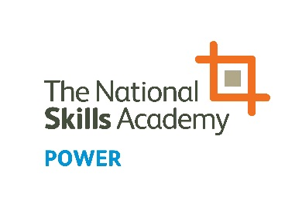
NOMINATION FORM
Best Learning and Development Initiative Award

The People in Power Awards aim to highlight, celebrate and inform others of the breadth of talent that exists in the power sector. Please click here to see all of the categories for this year’s awards.

Best Learning and Development Initiative
For a project, campaign or initiative which has significantly benefited learning and development in the workforce.

Initiative nominated:

Company:

Address:

Phone:

Email:

Nominated by:

Company:

Phone:

Email:

Please note:
Answers can be submitted as a video clip of no longer than 60 seconds per question, or written below. Individuals must not give their name or organisation in the clip/s as the awards are judged anonymously.

Q1: Tell us what you have done, who is involved and how it has made a difference
(max. 300 words)

Write your answer here or indicate if you are submitting your answer via video.

Q2: What were the business drivers for taking action and what impact have your actions had on the business as a whole? (max. 300 words)

Write your answer here or indicate if you are submitting your answer via video.

Q3: What advice would you give to other employers seeking to increase the skills of their workforce? (max. 300 words)

Write your answer here or indicate if you are submitting your answer via video.

To enter, complete the form and save on your computer. Then email the form and/or videos to communications@power.nsacademy.co.uk.
NOMINATIONS CLOSE AT 5PM FRIDAY 21 JUNE 2019

