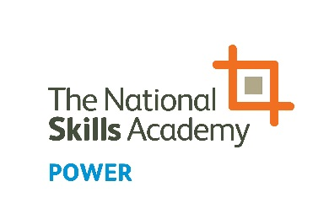
NOMINATION FORM
Outstanding Contribution to Health, Safety and the Environment Award

The People in Power Awards highlight, celebrate and inform others of the breadth of talent that exists in the power sector. Please click here to see all of the categories for this year’s awards.

Outstanding Contribution to Health, Safety and the Environment
For an individual who has made an outstanding contribution to health, safety and the environment.

Name of nominated person:

Company:

Address:

Phone:

Email:

Nominated by:

Company:

Phone:

Email:

Please note:
Answers can be submitted as a video clip of 60 seconds or less per question, or written below. Individuals must not give their name or organisation in the clip/s as the awards are judged anonymously.

Q1: Tell us what you/they have done, the reasons behind it, and how health, safety and the environment has improved (max. 300 words)

Write your answer here or indicate if you are submitting your answer via video.

Q2: What impact has this had on the organisation and/or the wider industry? (max. 300 words)

Write your answer here or indicate if you are submitting your answer via video.

Q3: What lessons have you/they learned which might be useful to others? (max. 300 words)

Write your answer here or indicate if you are submitting your answer via video.

To enter, complete the form and save on your computer. Then email the form and/or videos to communications@power.nsacademy.co.uk.
NOMINATIONS CLOSE AT 5PM FRIDAY 21 JUNE 2019

