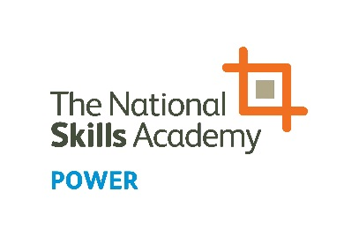
NOMINATION FORM
Rising Star Award – Power Apprentice of the Year

The People in Power Awards highlight, celebrate and inform others of the breadth of talent that exists in the power sector. Please click here to see all of the categories for this year’s awards.

Rising Star - Power Apprentice of the Year
An individual undertaking an apprenticeship in the power sector whose achievements and passion have inspired others.

Name of nominated apprentice:

Company:

Address:

Phone:

Email:

Nominated by:

Company:

Phone:

Email:

Please note:
Answers can be submitted as a video clip of 60 seconds or less per question, or written below. Individuals must not give their name or organisation in the clip/s as the awards are judged anonymously.

Q1: Tell us what drew you/them into an apprenticeship, what you/they have achieved and your/their plans for the future (max. 300 words)

Write your answer here or indicate if you are submitting your answer via video.

Q2: Describe what you/they do to inspire others and how this is making a difference (max. 300 words)

Write your answer here or indicate if you are submitting your answer via video.

Q3: What is your/their advice to parents, teachers or employers looking to inspire apprentices of the future? (max. 300 words)

Write your answer here or indicate if you are submitting your answer via video.

To enter, complete the form and save on your computer. Then email the form and/or videos to communications@power.nsacademy.co.uk.
NOMINATIONS CLOSE AT 5PM FRIDAY 21 JUNE 2019

