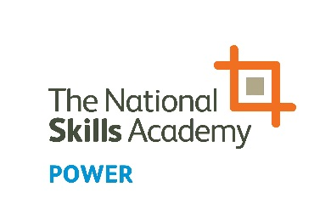
NOMINATION FORM
Training Provider of the Year – In-house team

The People in Power Awards highlight, celebrate and inform others of the breadth of talent that exists in the power sector. Please click here to see all of the categories for this year’s awards.

Training Provider of the Year
For a training provider that has delivered a training programme or initiative that has significantly benefited an employer/employers in the power sector.

Name of nominated training provider:

Company:

Address:

Phone:

Email:

Nominated by:

Company:

Phone:

Email:

Please note:
Answers can be submitted as a video clip of 60 seconds or less per question, or written below. Individuals must not give their name or organisation in the clip/s as the awards are judged anonymously.

Q1: Tell us what you have done, who is involved and how it has made a difference
(max. 300 words)

Write your answer here or indicate if you are submitting your answer via video.

Q2: What were the business drivers for taking action and what impact have your actions had on the business as a whole? (max. 300 words)

Write your answer here or indicate if you are submitting your answer via video.

Q3: What advice would you give to other training providers seeking to deliver excellence in rolling out training? (max. 300 words)

Write your answer here or indicate if you are submitting your answer via video.

To enter, complete the form and save on your computer. Then email the form and/or videos to communications@power.nsacademy.co.uk.
NOMINATIONS CLOSE AT 5PM ON FRIDAY 21 JUNE 2019

